1-What, exactly, is the DOM?

The Document Object Model, or the “DOM”, is an interface to web pages. It is essentially an API to the page, allowing programs to read and manipulate the page’s content, structure, and styles.

2-How is a web page built?

How a browser goes from a source HTML document to displaying a styled and interactive page in the viewport is called the “Critical Rendering Path”. Although this process can be broken down into several steps,these steps can be roughly grouped into two stages. The first stage : involves the browser parsing the document to determine what will ultimately be rendered on the page, and the second stage involves the browser performing the render.

3-How is the DOM created (and what does it look like)?

The DOM is an object-based representation of the source HTML document. It has some differences, as we will see below, but it is essentially an attempt to convert the structure and content of the HTML document into an object model that can be used by various programs.

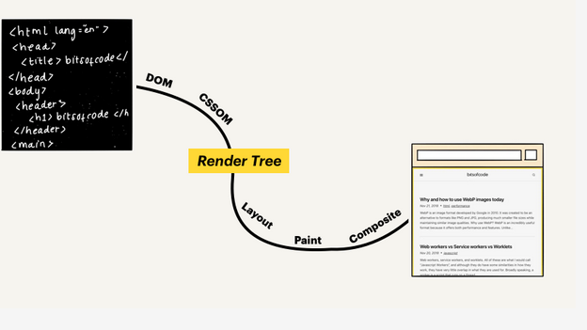

The object structure of the DOM is represented by what is called a “node tree”. It is so called because it can be thought of as a tree with a single parent stem that branches out into several child branches, each which may have leaves. In this case, the parent “stem” is the root <html> element, the child “branches” are the nested elements, and the “leaves” are the content within the elements.

**Let’s take this HTML document as an example:**

<!doctype html>
<html lang="en">
<head>
<title>My first web page</title>
</head>
<body>
<h1>Hello, world!</h1>
<p>How are you?</p>
</body>
</html>

This document can be represented as the following node tree:
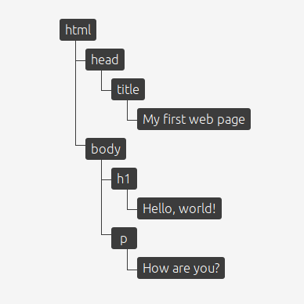

4- When the HTML is not valid

The DOM is an interface for valid HTML documents. During the process of creating the DOM, the browser may correct some invalidities in the HTML code.

Let’s take this HTML document for example:

<!doctype html>
<html>
Hello, world!
</html>

The document is missing a <head> and <body> element, which is a requirement for valid HTML. If we look at the resulting DOM tree, we will see that this has been corrected:

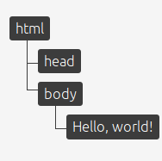

1-DOM:

Just to get things straight - DOM stands for Document Object Model and is an abstraction of a structured text.
For web developers, this text is an HTML code, and the DOM is simply called HTML DOM. Elements of HTML become nodes in the DOM.

So, while HTML is a text, the DOM is an in-memory representation of this text.

The HTML DOM is always tree-structured - which is allowed by the structure of HTML document.
This is cool because we can traverse trees fairly easily. Unfortunately, easily doesn’t mean quickly here.

React comes with a helping hand. ("Imagine that you have to tweak an event handler. If you lost the context, you have to dive really deep into the code to even know what’s going on. Both time-consuming and bug-risky.") The solution to this problem is declarativeness. Instead of low-level techniques like traversing the DOM tree manually, you simple declare how a component should look like. React does the low-level job for you - the HTML DOM API methods are called under the hood. React doesn’t want you to worry about it - eventually, the component will look like it should.

But this doesn’t solve the performance issue. And this is exactly where the Virtual DOM comes into action.

2-Virtual DOM

A virtual DOM object is a representation of a DOM object, like a lightweight copy.

First of all - the Virtual DOM was not invented by React, but React uses it and provides it for free.

The Virtual DOM is an abstraction of the HTML DOM. It is lightweight and detached from the browser-specific implementation details. Since the DOM itself was already an abstraction, the virtual DOM is, in fact, an abstraction of an abstraction.

so....There’s no big difference between the “regular” DOM and the virtual DOM. This is why the JSX parts of the React code can look almost like pure HTML:

In most cases, when you have an HTML code and you want to make it a static React component, all you have to do is:

*Return the HTML code in render
**Replace class attribute name to className - because class is a reserved word in JavaScript.

